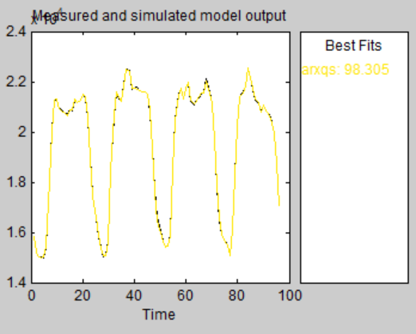

Zamirbek uulu Abdullakim

Excel data from 20.06-23.06

Model name: Linear regression model output

Accuracy percentage 98%